**<Nonprofit Name Here>**



**Earn Money for**

**by making a referral to**

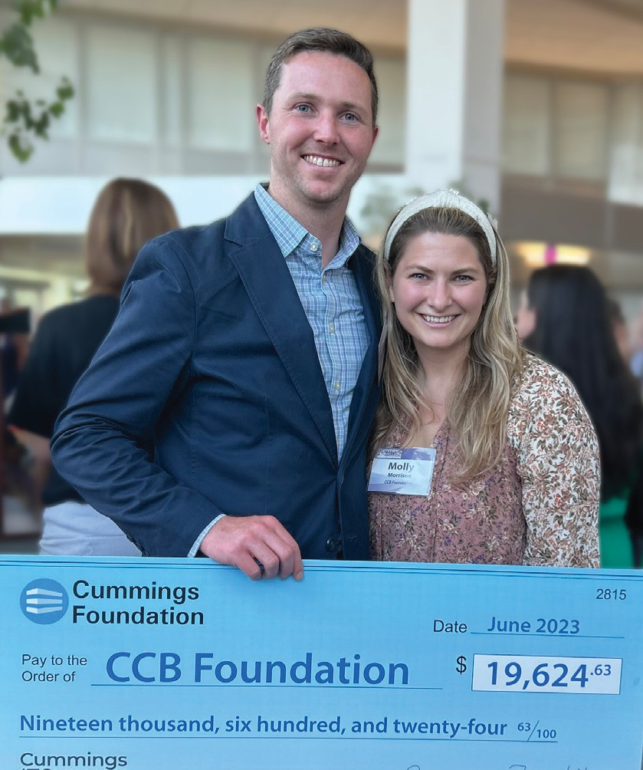Do you know someone looking to lease commercial real estate? Contact us with the details!

If your referral leases with **Cummings Properties**— ***where all profits go to nonprofits***— we could earn a donation equal to half the first year’s rent.

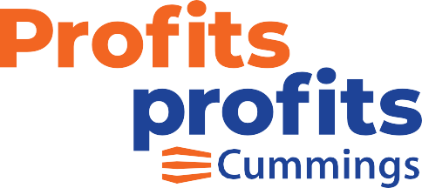

EXAMPLE REFERRAL

**2,000**

**square feet leased**

**$20**

**per   
square foot**

**$40,000**

**per year rent**

**$20,000**

**donation to your nonprofit**

Property Locations Space Types

* Andover
* Beverly
* Burlington
* Medford
* Somerville
* Stoneham
* Sudbury
* Wakefield
* Wilmington
* Woburn
* Office
* Laboratory

<Contact Information Here>

* Warehouse
* Medical
* Retail

**Contact Us Today!**

